**CRM APPLICATION THAT HELPS TO BOOK** **A VISA SLOT**

1.INTRODUCTION:

A visa slot management project is a system that is used to track and manage the availability of visa slots, which are appointments that are required for certain visa applications. It might be used by a government agency or a visa processing centre to schedule and manage appointments with applicants.

OVERVIEW

Salesforce is your customer success platform, designed to help you sell, service, market, analyse , and connect with your customers. Salesforce has everything you need to run your business from anywhere. Using standard products and features, you can manage relationships with prospects and customers, collaborate and engage with employees and partners, and store your data securely in the cloud. So what does that really mean? Well, before Salesforce, your contacts, emails, follow-up tasks, and prospective deals might have been organized something like this.

PURPOSE

A CRM system manages all your contacts and aggregates lead and customer information to build profiles of everyone you interact with. This gives you easy access to important information to better understand customer behaviour like purchase records and previous communications with contacts across different channels (chat, email, etc.). Customers won’t have to repeat their stories over and over to you, and you’ll be able to address issues with best practice and less effort for improved customer loyalty.

2. Problem definition & design thinking:

2.1. Empathy map

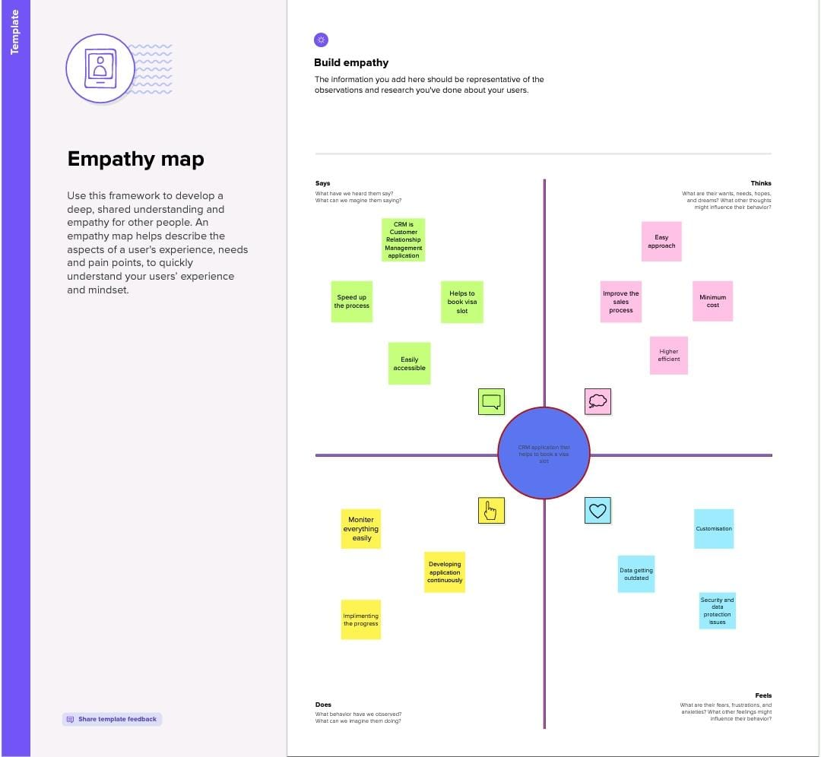

2.2. Ideation & Brainstorming:

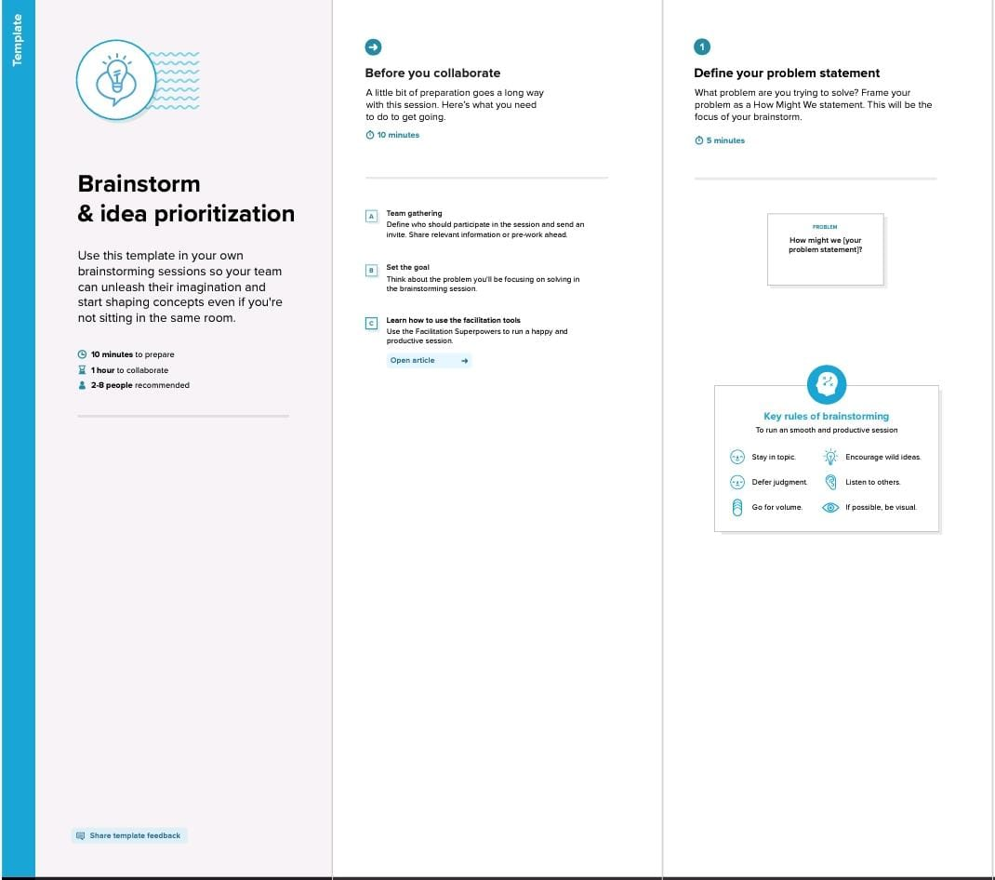

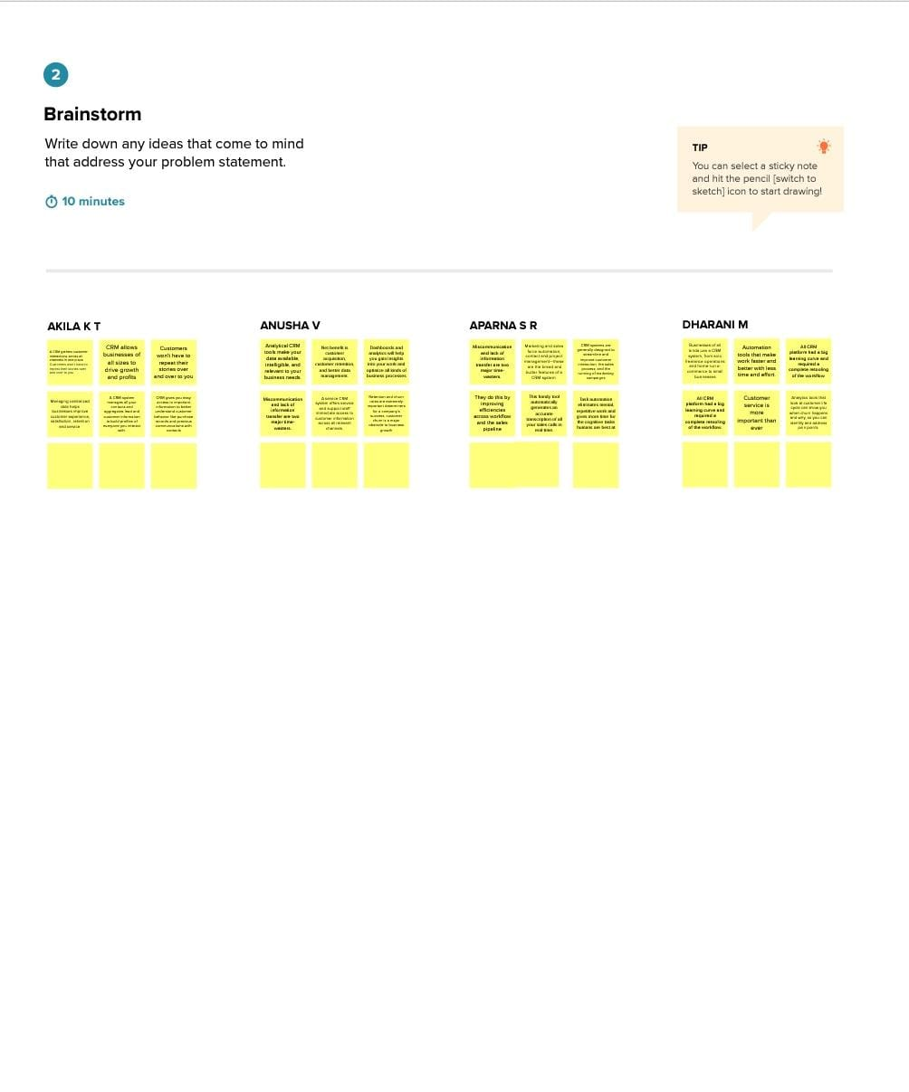

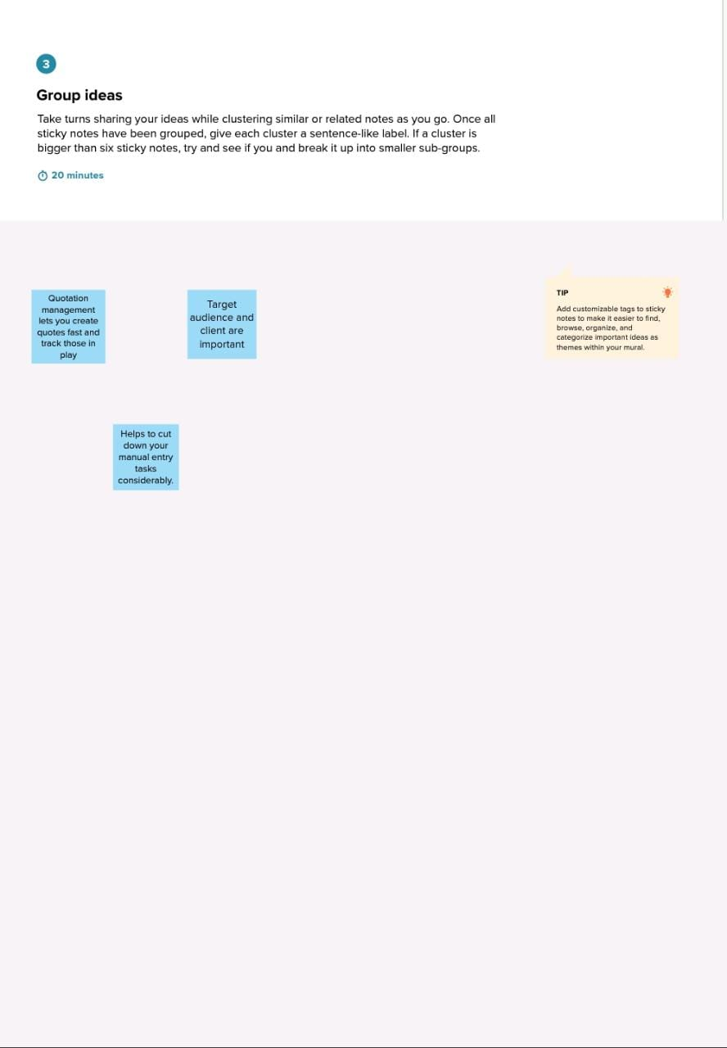

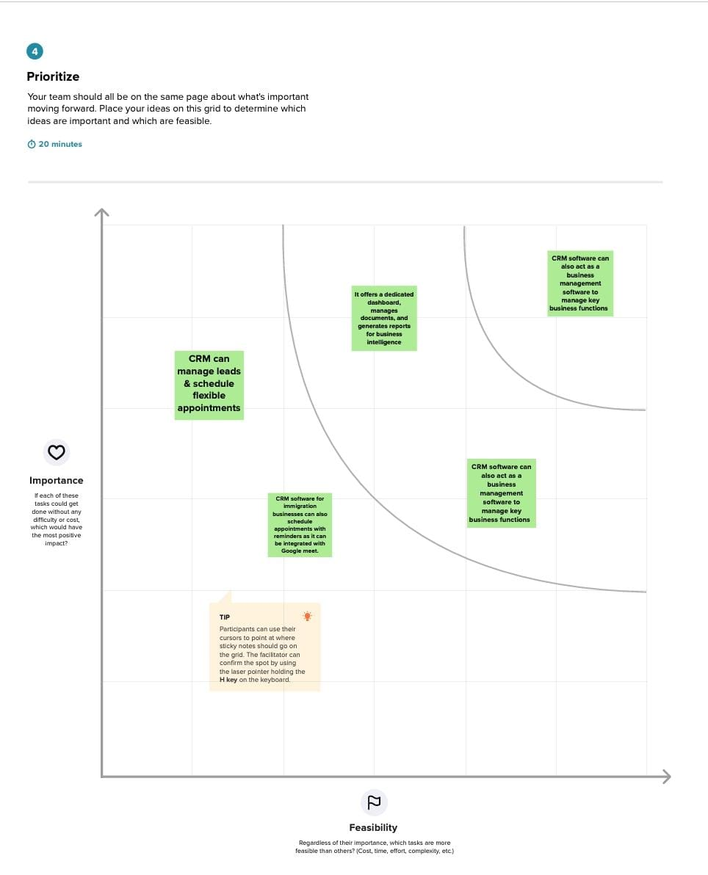

3.RESULT

3.1. Data Model

|  |  |
| --- | --- |
| OBJECT NAME | FIELDS IN THE OBJECT |
| Passport | |  |  | | --- | --- | | FIELD LABLE | DATA TYPE | | Full name | Text | | Passport number | Number | | Contact number | Number | | Permanent address | Text | |
| Visa slot | |  |  | | --- | --- | | FIELD LABLE | DATA TYPE | | Location | Text | | time | Time | | Passport number(master) | Master detail number(number) | | Visaslot number | Number | |
| Payment | |  |  | | --- | --- | | FIELD LABLE | DATA TYPE | | Payment mode | Text | | Card number | Number | | Transaction id(auto number) | Number | | Cancel transaction | Text | | Visaslot number(master) | Master detail number(number) | |

|  |  |  |  |  |  |  |  |  |  |  |  |  |  |
| --- | --- | --- | --- | --- | --- | --- | --- | --- | --- | --- | --- | --- | --- |
| Reschedule/ Cancel | |  |  | | --- | --- | | FIELD LABLE | DATA TYPE | | Passport number(master) | Master detail number(number) | | Location | Text | | Time | Time | | Cancel | Text | | Status | Text | |

Activity:1

Creation of custom object:

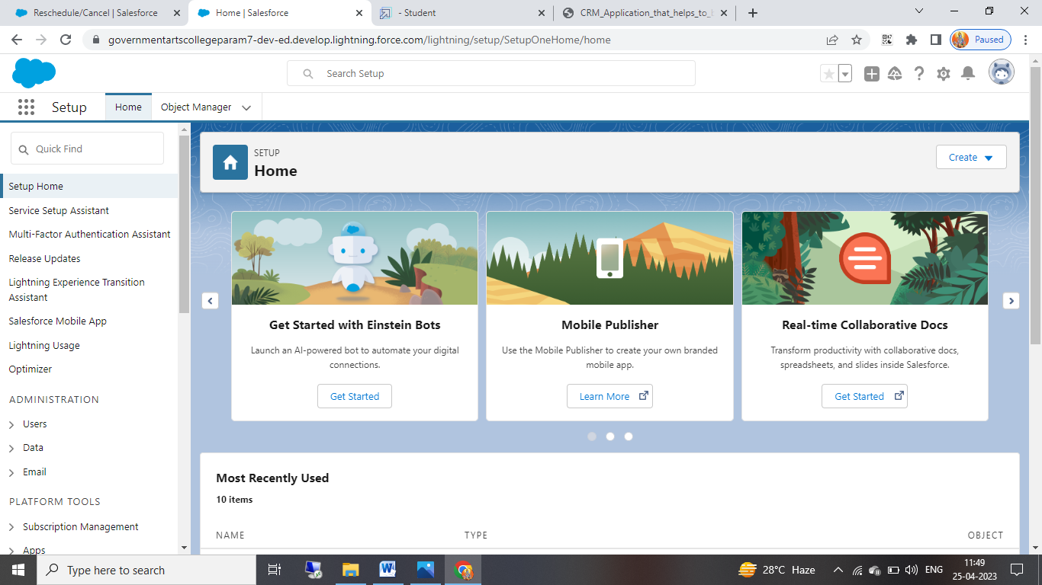

Object name: passport

Label : passport

Plural label : passports

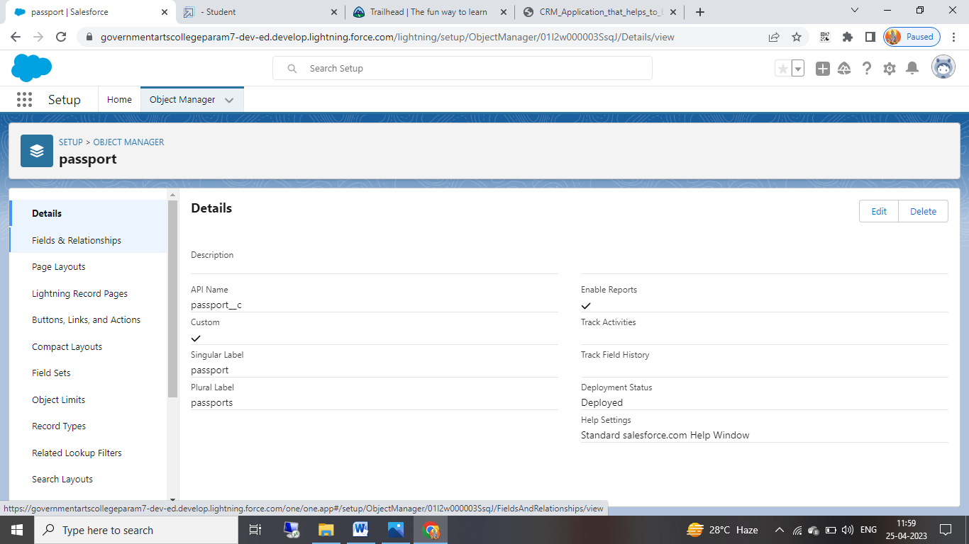

Object : Visa slot

Label: Visa slot

Plural label: Visa slots

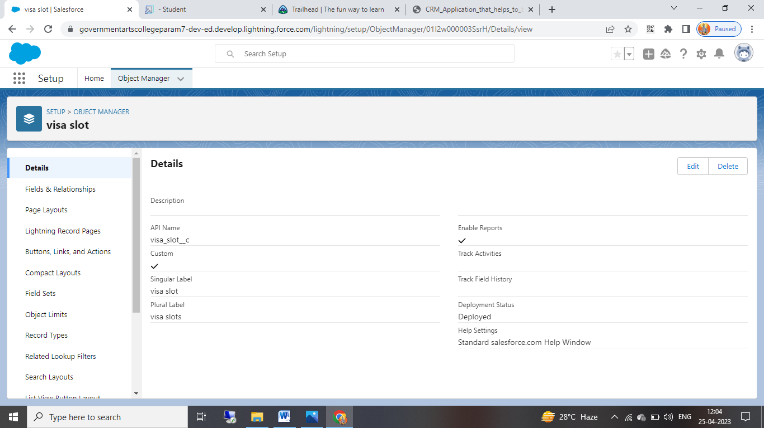

Object: Payment

Label: payment

Plural Label: payments

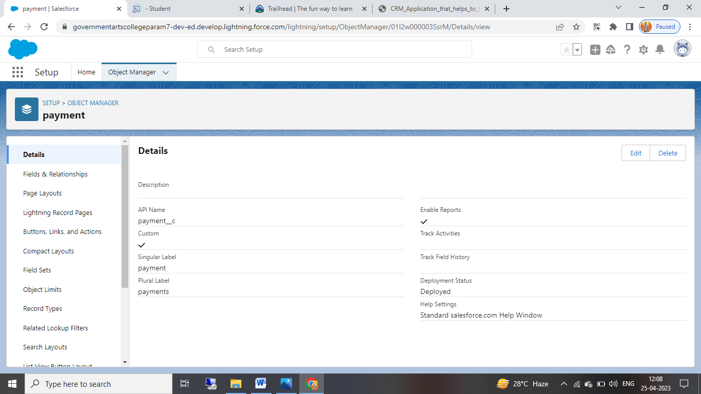

Object: Reschedule\cancel

Label: Reschedule\cancel

Plural label: Reschedule\cancel

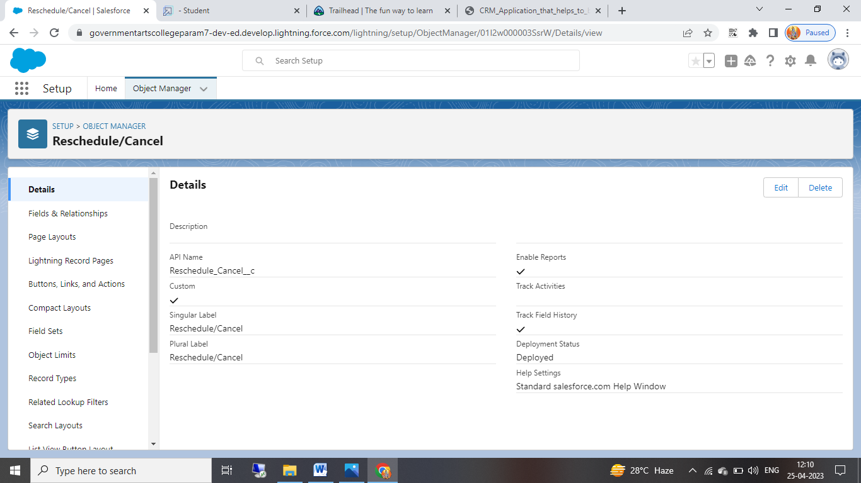

Milestone 3: Relationship between objects

Object : Passport

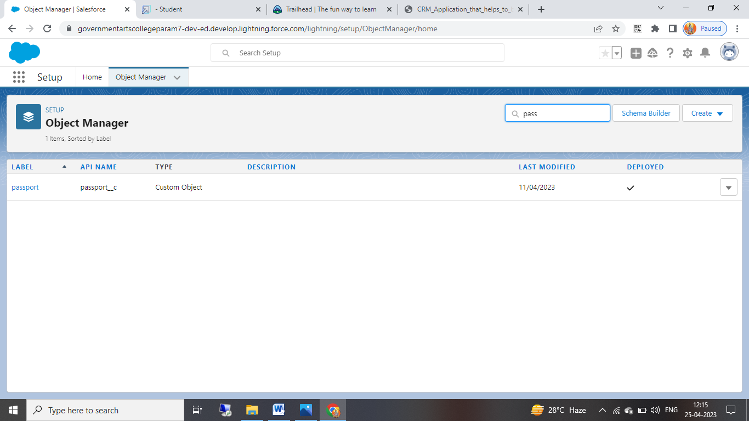

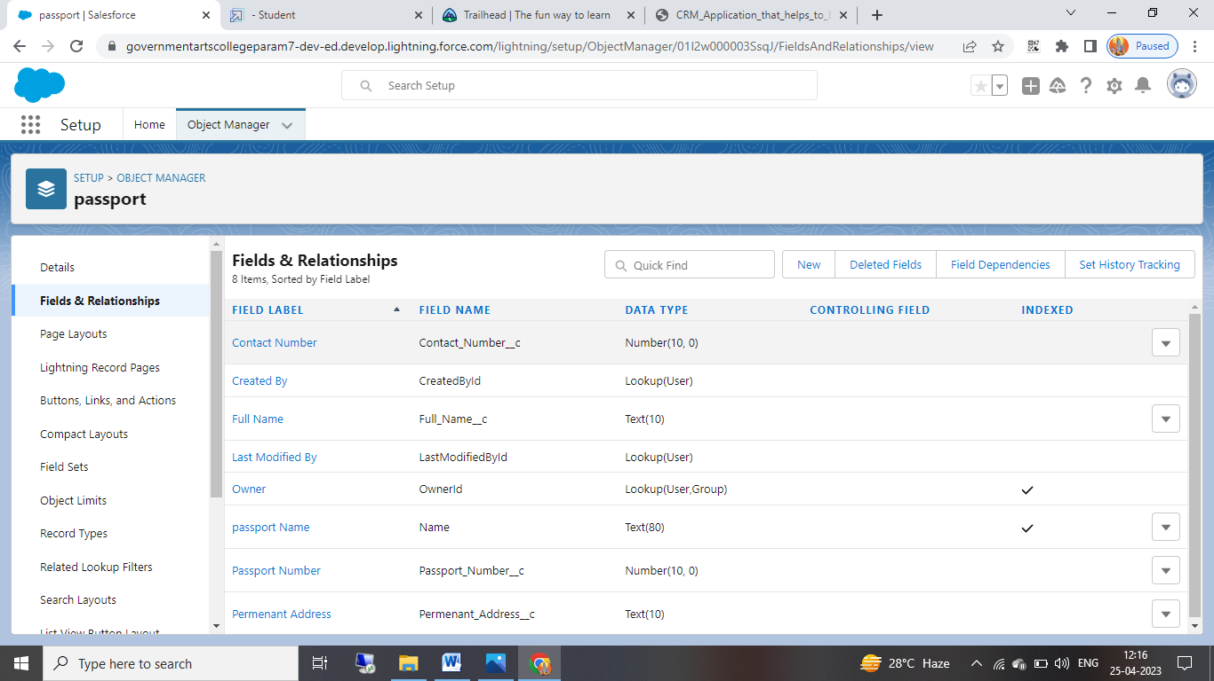

Object: visa slot

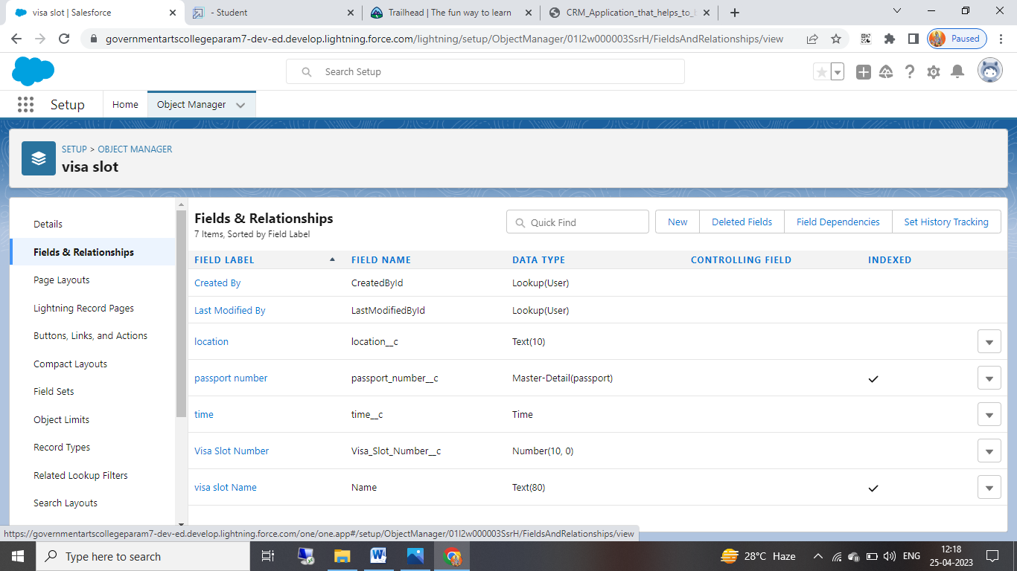

Object : Payment

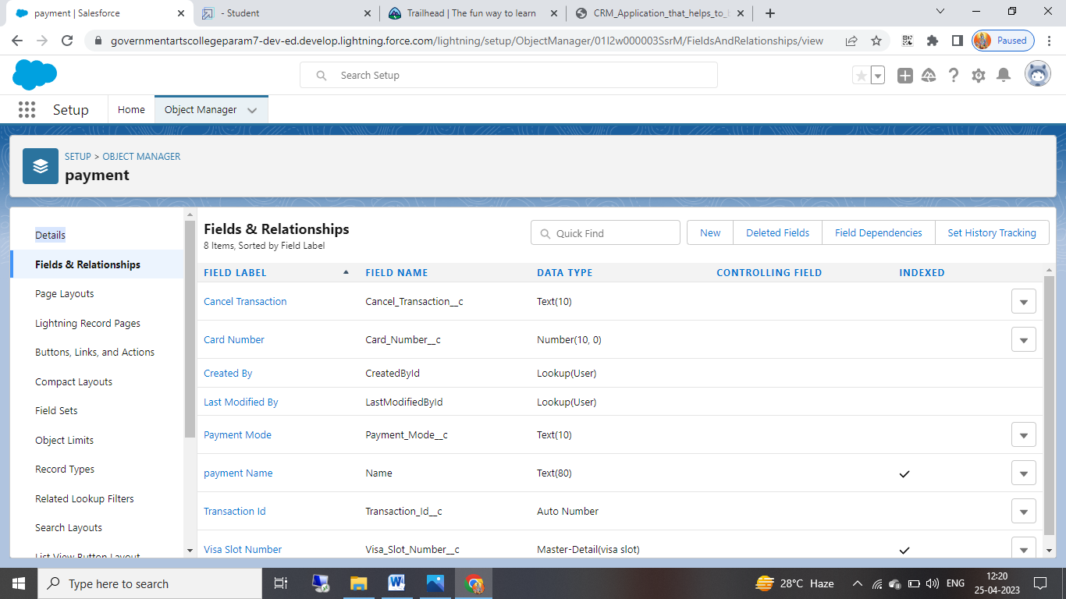

Object : Reschedule\Cancel

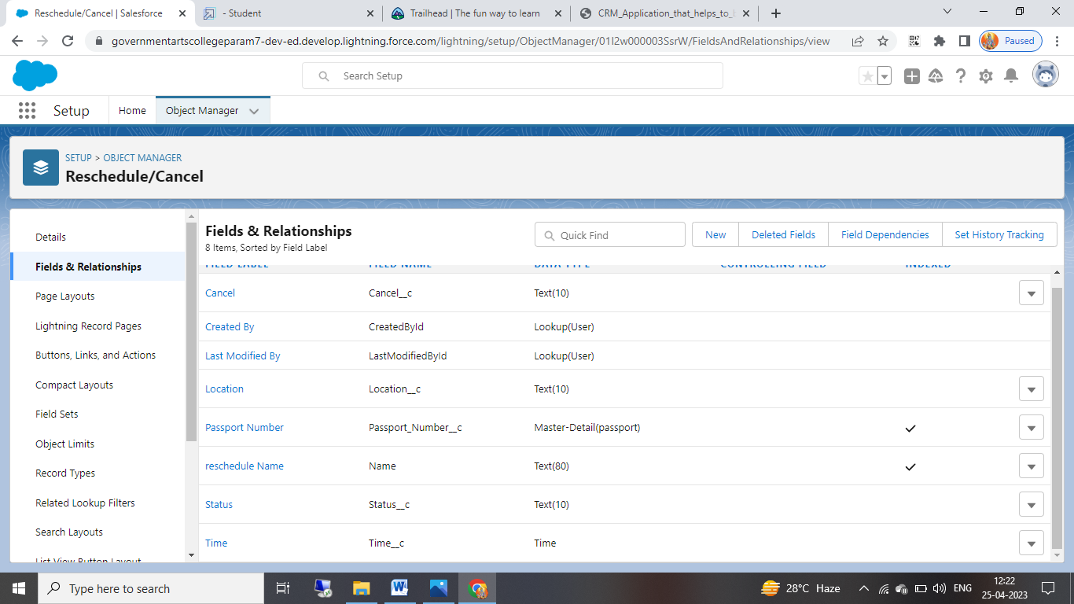

Milestone 4: APP

Apps in Salesforce are a group of tabs that help the application function by working together as a unit. It has a name, a logo, and a particular set of tabs. The simplest app usually has just two tabs. There are two types of Salesforce Applications:

1) Standard App

2) Custom App

Creation of App :

An app is a collection of items that work together to serve a particular function. Salesforce apps come in two flavors: Classic and Lightning.

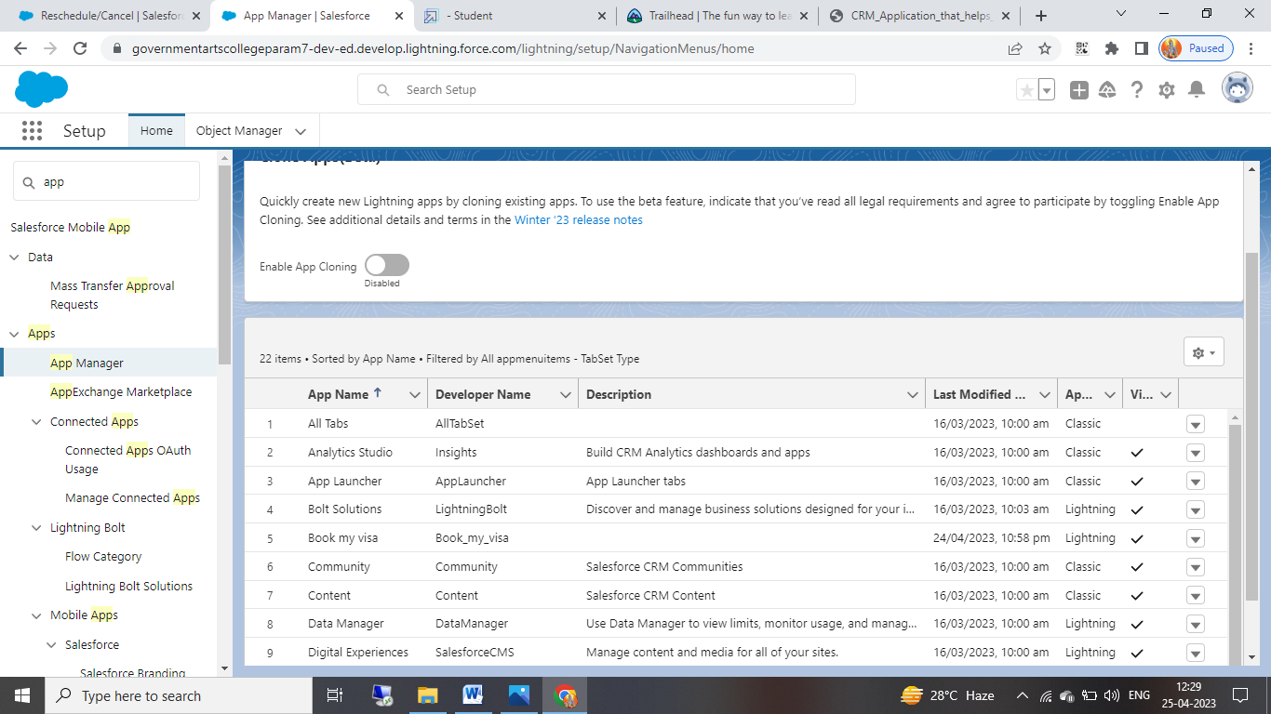

Milestone 5 : USER

A user is anyone who logs in to Salesforce. Users are employees at your company, such as sales reps, managers, and IT specialists, who need access to the company's records. Every user in Salesforce has a user account.

**Activity-1:**

**Creation of User**

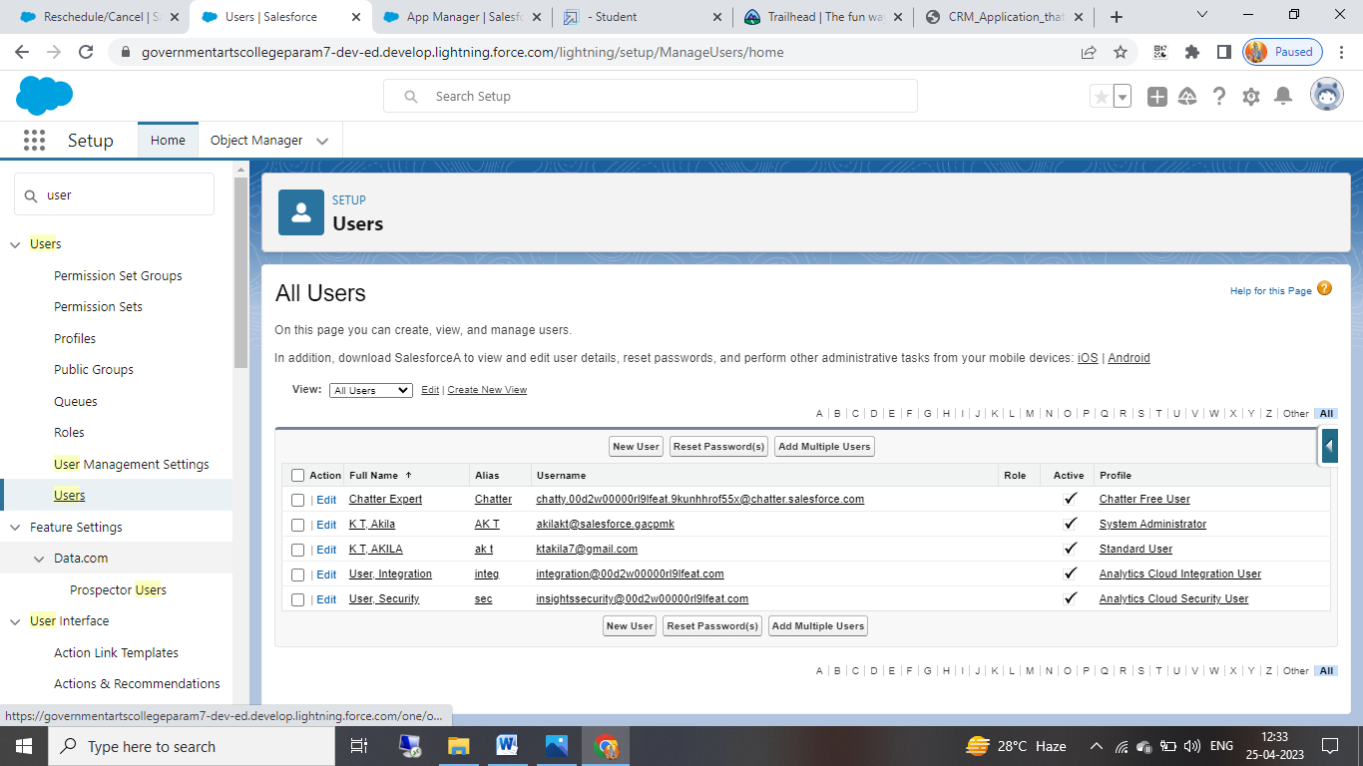

**Activity-2:**

OWD : organization wide default settings, This can be used to give permissions to the organization wide and it can be used for restrict the access, we can control the record level access

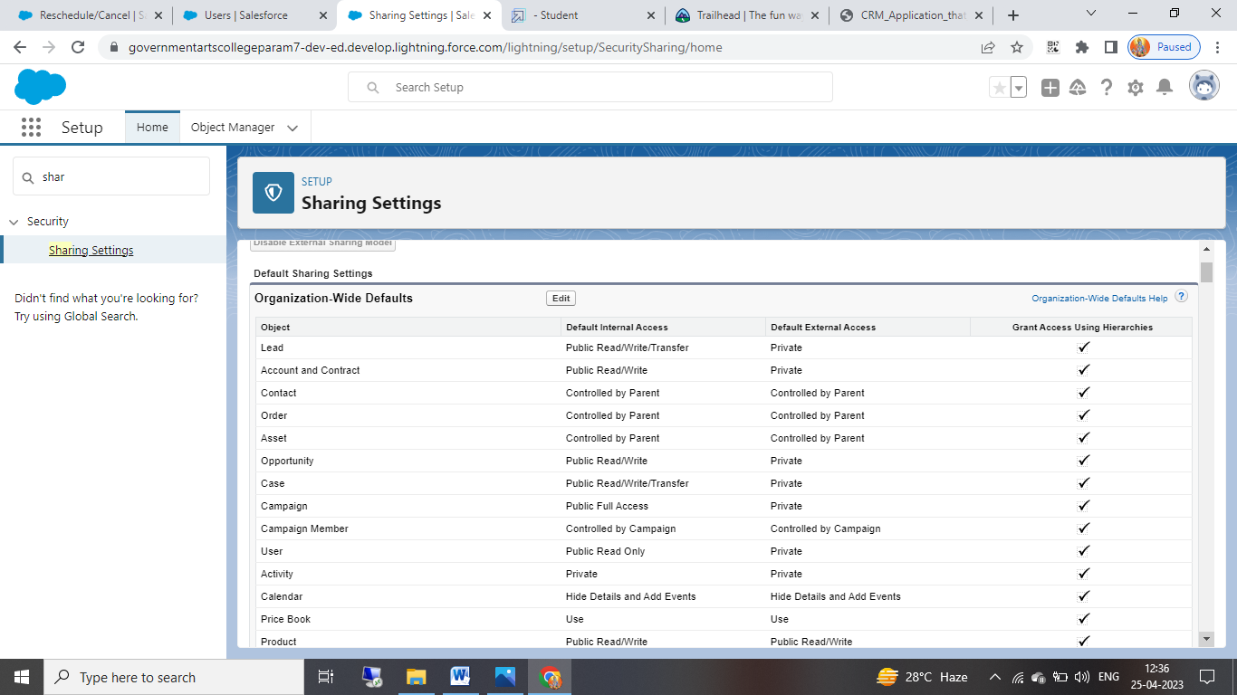

Miilestone 6: REPORTS

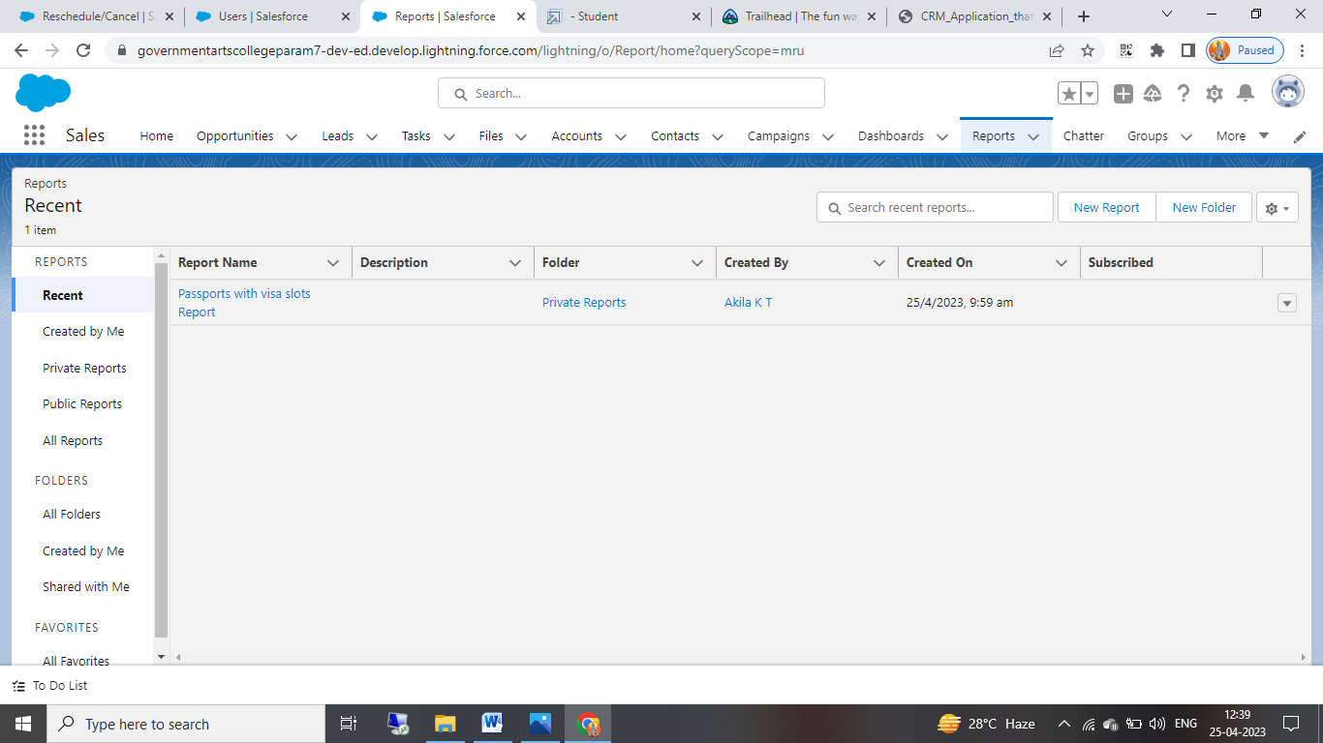

TRAILHEAD PROFILE PUBLIC URL:

Team lead: <https://trailblazer.me/id/akikt2>

Team member 1: <https://trailblazer.me/id/anusv14>

Team member 2: <https://trailblazer.me/id/kshanthi5>

Team member 3: <https://trailblazer.me/id/ykesavan>

ADVANTAGES AND DISADVANTAGES:

ADVANTAGES:

* Students can gain knowledge to solve a problem and know the solutions.
* Students will gain communication and team-player skills.
* Opportunities for creativity.
* Ability to work on different event.
* Change to work with diverse clients.
* Collaborative work environment.
* High projection for job growth.
* Lot of knowledge base.
* Easy to create events and objects

**DISADVANTAGES:**

* This project needs a system to fulfil it.
* Sometimes signal is rarely appearing due to server problem.
* Unconventional work hours.
* Time away from family and friends.
* Experience requirements.
* Multiple events at the same time.
* High level of responsibility.

**APPLICATIONS:**

A CRM system manages all your contacts and aggregates lead and customer information to build profiles of everyone you interact with. This gives you easy access to important information to better understand customer behaviour like purchase records and previous communications with contacts across different channels (chat, email, etc.). Customers won’t have to repeat their stories over and over to you, and you’ll be able to address issues with best practice and less effort for improved customer loyalty.

**CONCLUSION:**

In this project salesforce . We learned to create object , knowledge we gained during this pro s , fields, tab fields, tab s, apps, apps, profile in salesforce project and how to use them systems are powerful tools that he . CRM application that helps us to book visa slot easily. These systems offer a range of features and functionalities that automate many time consuming tasks, streamline communication, enhance attendee engagement future planning. , and provide valuable insights for future bookings.